# Guide: SelfHelp Project Deletion

The deletion of a project is shown in this guide using the example of the **deathapp** project. To delete a project completely, proceed as follows:

The command *rm -rfv deathapp/* will remove the directory called "deathapp" and all of its contents, and display the details of what is being deleted.

All files and directories in the "deathapp" directory will be permanently deleted without any confirmation prompts, and the command will display the names of the files and directories as they are being deleted. This is a potentially dangerous command, so be sure to double-check the directory you are removing before executing the command, and make sure you have a backup of any important files before removing them!

becccs@becccs~$ **rm –rfv deathapp/**



Log into the MySQL server with a user with the appropriate rights and delete the project database:

becccs@becccs:~$ **mysql –u ns21f217 -p**

Enter the password in the prompt and then switch to the corresponding database_

**USE deathapp**;

Delete the entire database:

**DROP DATABASE deathapp**;

Exit the MySQL server:

**quit**;

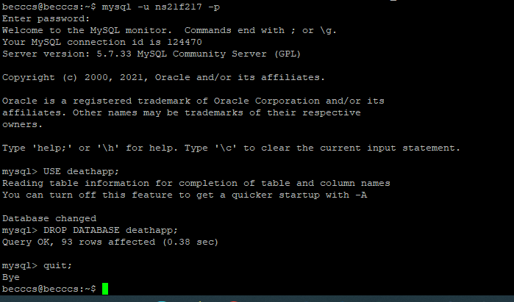

Search and delete leftover (configuration) files on the server:

becccs@becccs:/etc/apache2/sites-available$ **sudo rm deathapp.conf deathapp_ssl.conf**



becccs@becccs:/etc/apache2/sites-enabled$ **sudo rm deathapp.conf deathapp_ssl.conf**



To remove a Let's Encrypt certificate obtained with Certbot, you can use the *certbot delete* command. List all the certificates on the server:

becccs@becccs~$ **sudo certbot certificates**

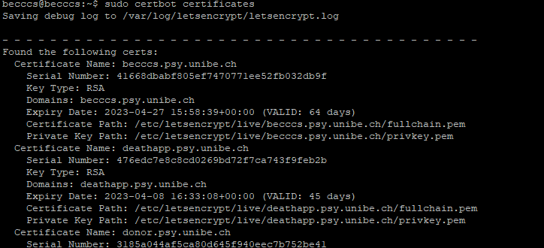

Find the certificate for "deathapp.psy.unibe.ch". Run the following command to remove the certificate:

becccs@becccs~$ **sudo certbot delete --cert-name deathapp.psy.unibe.ch**

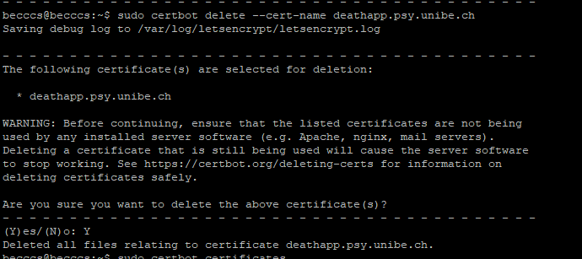

Also ask to remove the Alias from the Host (Netadmin Alias/CName).

Also delete the cronjob for the project:

$ crontab -e